# Group Project Documentation C# Programming and Unity

*Group 8*

**Prepared by Group 8**

1. ***Hồ Tâm Phong***
2. ***Nguyễn Thái Hoàng***
3. ***Quách Hoàng Huy***
4. ***Nguyễn Hữu Anh Duy***

Ho Chi Minh City, 2024

**Table of Contents**

**1.** **Game Introduction 1**

**2.** **How to play 1**

**3.** **Game Design Specification**

**4. Member Task**

**5****.** **Project Management 2**

**6****.** **Implementation 2**

**6****.1.** **Deployment Considerations 2**

**6****.2.** **Screenshots and explanations** 2

**7****.** **References 2**

**Revision History**

| **Name** | **Date** | **Reason For Changes** | **Version** |
| --- | --- | --- | --- |
| Duy | 10/06 | add character, movement, cải thiện lại map | 2022.3.28f1 |
|  |  |  |  |
|  |  |  |  |
|  |  |  |  |
|  |  |  |  |

# Game Introduction

**Tiny RPG Forest** is a 2D Unity asset pack that provides you with everything you need to create a complete top-down RPG game from scratch. It includes characters, environment graphics, template code, and more.

**Features:**

* 16 fully animated 2D characters
* 4 different forest environments
* Top-down graphics
* Template code for movement, combat, and inventory systems
* Easy to use and customize

# How to Play

## Game Startup Screen

**Start:** Choose to start a new game.**Continue:** Choose to continue from a previously saved game.**Options:** Adjust audio, brightness, and language settings.**Exit:** Exit the game.

## Opening Storyline

Watch a cutscene as the main character enters the town of Everwood. Talk to the village chief to receive the first quest.

## Exploring Everwood Town

**Movement:** Use the arrow keys or W, A, S, D to move the character around the town.**Town Map:** Explore important locations such as the village chief's house, tavern, shop, market, and ancient library.**Interaction:** Press Enter or Space to interact with NPCs and objects in the game.

## Accepting and Completing Quests

**Accepting Quests:** Talk to NPCs to receive quests. Quests may involve finding items, helping villagers, or exploring new areas.**Tracking Quests:** Use the quest log to track accepted quests. The quest log can be accessed by pressing Q.**Completing Quests:** Complete quests to receive rewards such as money, equipment, or new skills.

## Combat

**Encountering Monsters:** When moving outside of town or into dungeons, you will encounter monsters.**Turn-Based Combat System:**

* **Attack:** Choose to attack to deal damage to the monster.
* **Defend:** Choose to defend to reduce damage taken during the monster's turn.
* **Skills:** Use special skills that the character has learned.
* **Items:** Use items to heal or increase stats.
* **Victory:** Upon defeating monsters, you will gain experience and rewards.

## Exploration and Puzzles

**Town Secrets:** Uncover the secrets of Everwood town through clues and quests.**Puzzles:** Solve puzzles to unlock new areas or receive special rewards.

## Game Ending

Upon completing the main quest, you will solve the mystery of the town. You can choose to continue exploring side quests or end the game.

**Additional Notes:**

* This is a basic outline of a game tutorial. The specific details will vary depending on the game.
* Be sure to include screenshots or videos to illustrate your points.
* Use clear and concise language that is easy for beginners to understand.
* Break down the tutorial into small, manageable steps.
* Use a consistent format throughout the tutorial.
* Proofread your tutorial carefully before publishing it.

# Game Design Specification

Tools: Drawio, Visual Paragram, Vẽ giấy,......

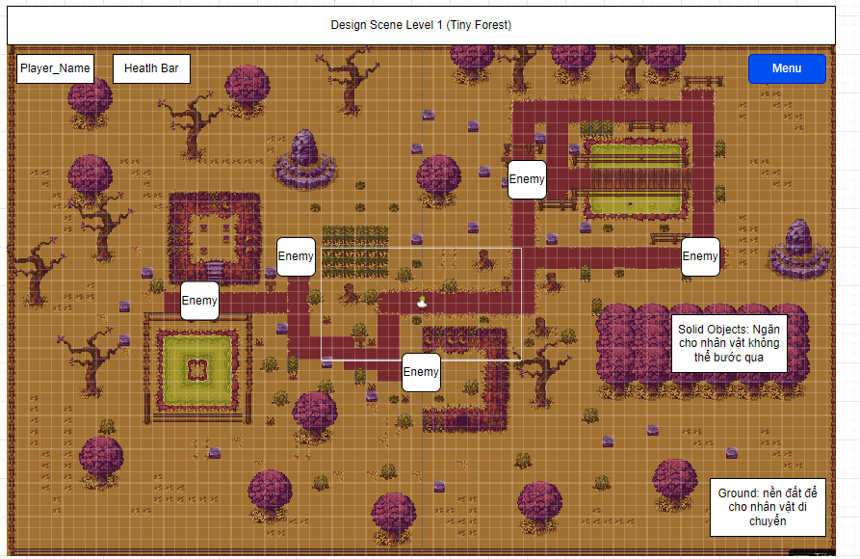

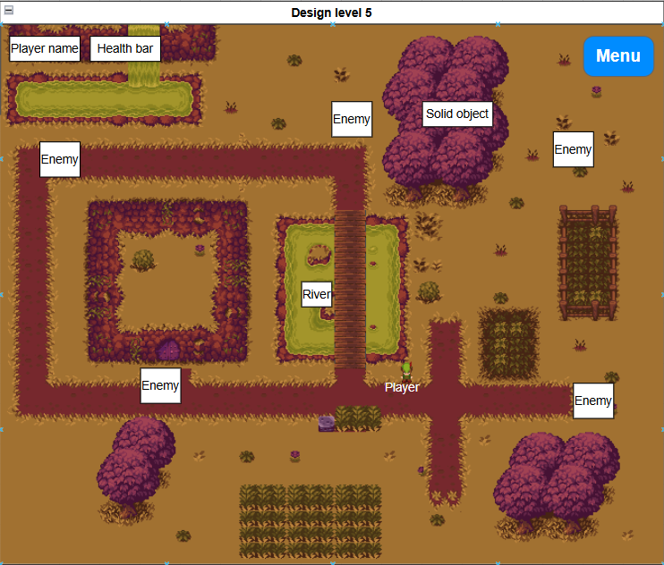

# Project Management

| # | Task name | Member | Note |
| --- | --- | --- | --- |
| 1 | Project Prototype - Tiny Forest | Group 8 | Download Assets from Unity store – Unity version 2022.3.28f1 |
| 2 | Design Scene level 1 + Docs | Nguyễn Hữu Anh Duy (90%) | chưa có player_name, sound |
| 3 | Design Scene level 2 + Menu | Hồ Tâm Phong (-) | chưa có |
| 4 | Design Scene level 3 + 4 | Quách Huy Hoàng (-) | chưa có |
| 5 | Design Scene level 5 + How to play | Nguyễn Hoàng Thái (-) | chưa có |
| 6 | Kịch bản - Cách chơi | Nguyễn Hữu Anh Duy (100%) | đã xong kịch bản và cách chơi |

# Implementation

## Deployment Considerations

## Screenshots and explanations

# References

1. *Asset Store:*

[*https://assetstore.unity.com/packages/2d/characters/tiny-rpg-forest-114685*](https://assetstore.unity.com/packages/2d/characters/tiny-rpg-forest-114685)

*[2]. Enemy:*

[*https://opengameart.org/content/skeletons-rework*](https://opengameart.org/content/skeletons-rework)